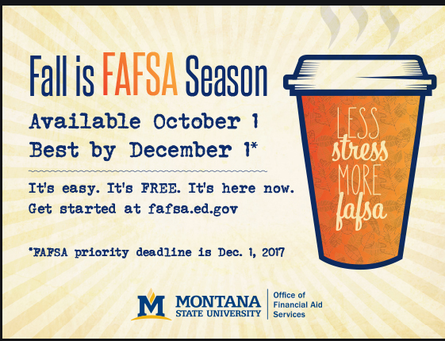

GOAL: Students to submit FAFSA/TASFA/Sch. Application🡪 Flyer idea above.

T shirts- Order 200 shirts for students- additional shirts for FA staff to wear leading up to event day and event day. Back- the coffee cup on the back - #MoneyDaze2K21 – Sponsored by “The Office of Financial Aid and Scholarships” – around the outside of the cup. Front- a lion head & #MoneyDaze2K21 (Same font as “back 1”.

**Color of shirt- khaki yellow, “coffee cup back 1”,**

9/30, October 1, October 2 list serve- Subject: “#MoneyDaze is back!” we are going to be (location) show us proof that we did the FAFSA/TASFA/Scholarship application and following on social media, on Campus event. Students enrolled in CBE are not applicable for this scholarship. However can participate in all other prizes.

Promote through handshake- promote on the t.v. in student center, list serve **– Christi**

Promotion Flyers- Latson’s **Kevin** – **sarah g.** design flyers – **Success Team Advisors** break up campus and put in all buildings (stamp approved for students center)

Jonathan- Risk assessment, tents, location (crossroads)

**Sarah G.** - Social media promotion

Tshirt design- **Sarah G.**

Event: October 5th 11am-2pm/ October 6th 9am-1pm/ October 7th – 1pm-4pm. Location ideas: Crossroads (Ag building)

Purpose: Show proof of following social media- free coffee and hot chocolate (Mugs), (Cup sleeves Lion and Mugs stamped- be on the cups already), cookies and brownies individually wrapped (Mugs). FAFSA/TASFA/ Scholarship Application confirmation email – First 200 free t-shirts.

Note- Let Kathy/Katy know to look at those emails for TASFA

Checkin- Corq. No app? Excel sign in. (still in discussion)

Promotion:

(10) $5, Lion Cash

(3) Walmart/bookstore lion apparel $100 – tumblers, etc.

(4) $500 scholarships (FA or VP BONDS)

(6) “Too Good popcorn” prize basket

Movie basket, laundry basket, game basket, school supply basket

Budget- Want to stay under $1,000. –

$650 100 shirts plus 30 staff shirts @ 2 colors $5 each shirt.

Once signed in to the event by showing the email confirmation- will do the raffle off site and email student the prize. Will set up a time in the alumni center to take a picture with prize in the alumni center

Latsons- flyers for campus (75)

RE-EVALUATION-

Portray as Work study mixer-

Incentives: Free shirts

Hot cocoa packets,

Set up tables alphabetically for t-shirts